BAZY DANYCH

# PROJEKT – ETAP 4

**Autorzy:**

Igor Michalski

Marcel Browarny  **Termin:**

PT/TP 11:15

Wrocław, 08.01.2018 r.

1. Normalizacja

Tu trzeba opisać co robimy po kolei (ew. nie zmieniamy nic na danym etapie normalizacji). Etapy 1-3 prawdopodobnie są spełnione przepisując po prostu diagram związków encji. Rzuć okiem na ten punkt w wolnej chwili 😊

1. 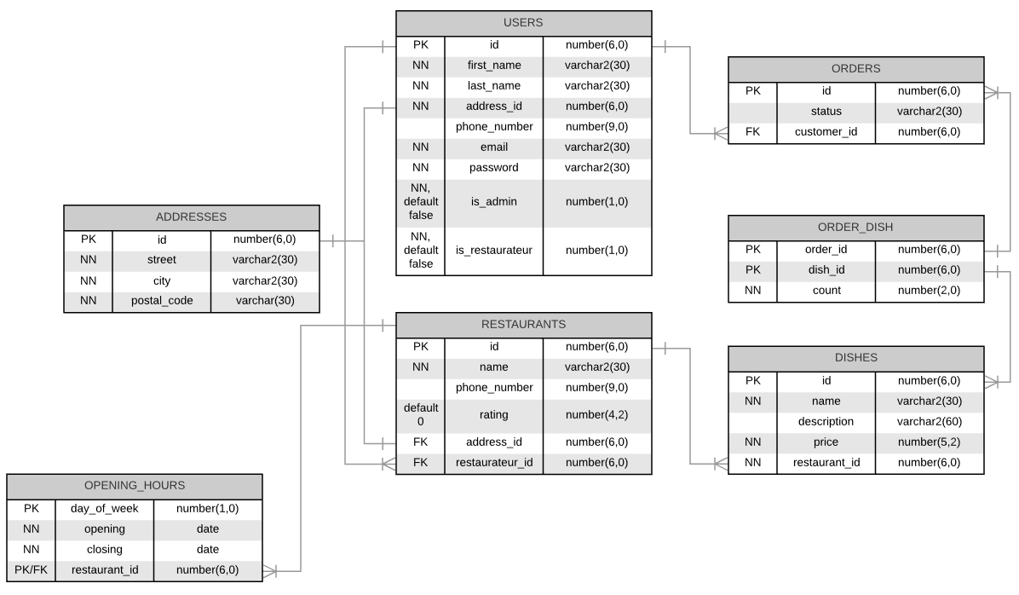Końcowy schemat bazy danych
2. Tworzenie tabel

-- ADDRESSES

create table addresses

(

id number(6,0) primary key,

street varchar2(30) not null,

city varchar2(30) not null,

postal_code varchar2(30) not null

);

-- USERS

create table users

(

id number(6,0) primary key,

first_name varchar2(30) not null,

last_name varchar2(30) not null,

email varchar2(30) not null,

password varchar2(30) not null,

phone_number number(9,0),

is_admin char default '0' not null check(is_admin in ('0', '1')),

is_restaurateur char default '0' not null check(is_restaurateur in ('0', '1')),

address_id number(6,0) not null references addresses(id)

);

--ORDERS

create table orders

(

id number(6,0) primary key,

status varchar2(30),

customer_id number(6,0) not null references users(id)

);

-- RESTAURANTS

create table restaurants

(

id number(6,0) primary key,

name varchar2(30) not null,

phone_number number(9,0),

rating number(4,2) default '0',

address_id number(6,0) not null references addresses(id),

restaurateur_id number(6,0) not null references users(id)

);

-- OPENING_HOURS

create table opening_hours

(

day_of_week number(1,0) not null check(day_of_week between 1 and 7),

opening date not null,

closing date not null,

restaurant_id number(6,0) not null references restaurants(id),

primary key (day_of_week, restaurant_id)

);

-- DISHES

create table dishes

(

id number(6,0) primary key,

name varchar2(30) not null,

description varchar2(100),

price number(5,2),

restaurant_id number(6,0) not null references restaurants(id)

);

-- ORDER_DISH

create table order_dish

(

order_id number(6,0) not null references orders(id),

dish_id number(6,0) not null references dishes(id),

count number(2,0) not null,

primary key(order_id, dish_id)

);